PHYS 221 Elements of Physics I Fall 2021
Recitation and Laboratory
Department of Physics and Astronomy
University of Tennessee, Knoxville

Course Section: 001
Meeting Time and Place: Friday 10:10-11:00 AM Nielsen 608
Friday 11:15 AM -1:10 PM Nielsen 508
Course Credit Hours: 4
Prerequisites: Mathematics 130 or 125 or 141 or 151 or 152 or any calculus course.

Graduate Teaching Assistant Contact Information
Mr. Rusty Hound
Office Hours: Tutorial Center Nielsen 203 W 1:15-2:25 PM or by appointment
Office location: Nielsen 605
865-974-Paws
RustyHound@utk.edu

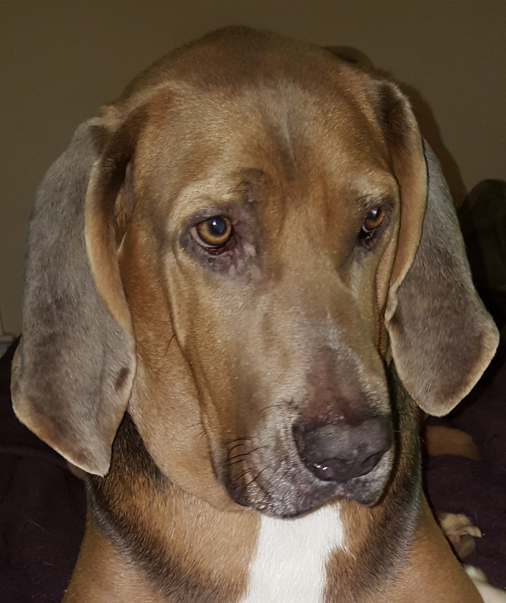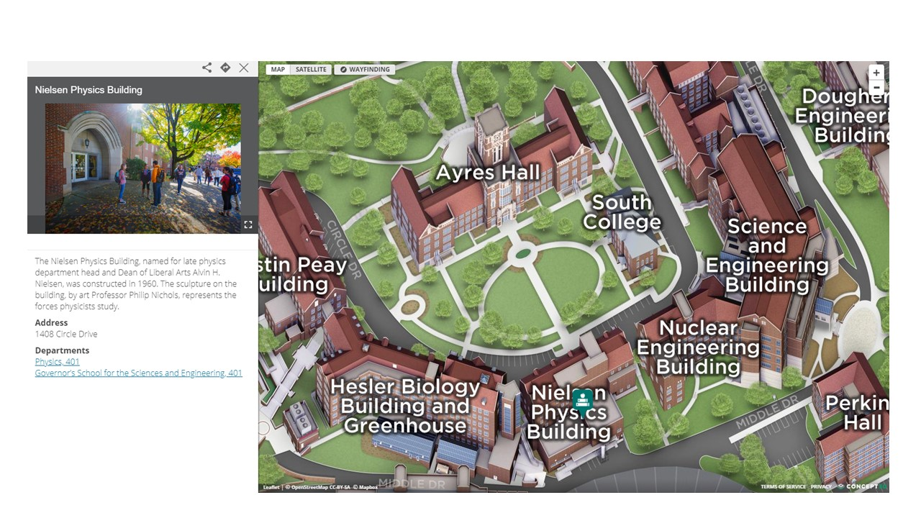

Course Description/Information:
Basic physical principles and applications required in pre-medical, pre-pharmacy, and pre-veterinary programs. Mechanics, heat, and wave motion.

Student Learning Outcomes/Objectives:
The lab and recitation will give hands-on experience with problem solving and with equipment. The lab material will enhance student learning of underlying physics principles. Students should also understand measurements that they take and the confidence in those measurements. Students will also learn to write up their results so that they can clearly communicate them to an outside reader.

Learning Environment:
Students should come prepared with questions regarding problem solving and be ready to participate in problem solving. They should have read the lab material prior to coming to lab and have done the prelab. They are expected to fully participate in all aspects of lab and write an individual report, as required.

Course Communications:
Communication is best through email or office hours. If you need to meet outside of office hours, that can be arranged through email. For technical issues, contact the OIT HelpDesk via phone (865) 974-9900 or online at http://help.utk.edu/.

How to Be Successful in This Course:
Student’s Responsibility
- Be prepared for all classes
- Be respectful of others
- Actively contribute to the learning activities in class
- Abide by the UT Honor Code
Instructor’s Responsibility
- Be prepared for all classes
- Evaluate all fairly and equally
- Be respectful of all students
- Create and facilitate meaningful learning activities
- Behave according to University codes of conduct

Texts/Resources/Materials:
The laboratory manual for Physics 221 is Contemporary Introductory Physics Experiments, 2nd Edition by James E. Parks, Hayden-McNeil Publishing, ISBN 978-0-7380-6168-9 and is available at the UT Book and Supply Store.

Course Resources:
Canvas Course Site
http://www.phys.utk.edu/physlabs/schedules.html

Course Requirements, Assessments, and Evaluations:
- The lab schedule can be found at http://www.phys.utk.edu/physlabs/schedules.html
- Students should be present at every recitation and lab period. If a student is ill or has a reasonable excuse, they should email their GTA before class starts. They may be given an alternate online lab to do at home if making up the lab in-person is not feasible.
- A prelab will be due at the beginning of each recitation that coincides with the laboratory session for that day.
- There will be two formal lab report write-ups. They will be on the Conservation of Energy lab and the Boyle’s Law lab.

Grading:
- Recitation 10%
- Prelab Assignments 10%
- Lab Participation 10%
- Short Lab Reports 40%
- Formal Lab Report 1 15%
- Formal Lab Report 2 15%

Short Lab Report Rubrics:
Section | Details | Possible Points
Abstract | Summarized the important physical principle being studied, how it was studied, and the main result. | 2
Careful measurement and analysis resulting in high quality data | Includes appropriate graphs with title and x and y axis labeled. Final results with uncertainty displayed prominently. | 4
Questions from lab manual | Answer the questions assigned and show your work. | 2
Summary and Conclusions | Restate your results. State where sources of error could be. This should be with great thought (Do not say the equipment did not work.). For example, one could state that the measurements for distance were +/- 0.1 m or that friction seemed to be present when mass greater than 200 g were used. | 2
Total |  | 10
Formal Lab Report Rubrics:
Section | Details | Possible Points
Abstract | Summarized the important physical principle being studied, how it was studied, and the main result. | 2
Introduction | Includes the main physical principles studied and the main equations used in the experiment. It is not necessary to derive equations already found in the lab manual. | 3
Experimental Procedure | Include a description of what you did and the equipment used. It is not necessary to include every detail, but include enough detail that someone can understand the procedure. | 3
Careful measurement and anaylsis resulting in high quality data | Includes appropriate graphs with title and x and y axis labeled. Final results with uncertainty displayed prominently. | 5
Questions from lab manual | Answer the questions assigned and show your work. | 2
Summary and Conclusions | Restate your results. State where sources of error could be. This should be with great thought (Do not say the equipment did not work.). For example, one could state that the measurements for distance were +/- 0.1 m or that friction seemed to be present when mass greater than 200 g were used. | 3
Intelligibility and grammar | Clearly written and uses good grammar. | 2
Total |  | 20
The instructor reserves the right to revise, alter or amend this syllabus as necessary. Students will be notified in writing / email of any such changes.
Campus Syllabus

Dear Student,

The purpose of this Campus Syllabus is to provide you with important information that is common across courses at UT. Please observe the following policies and familiarize yourself with the university resources listed below. At UT, we are committed to providing you with a high-quality learning experience. I want to wish you the best for a successful and productive semester.

- Dr. John Zomchick, Provost and Senior Vice Chancellor

UNIVERSITY CIVILITY STATEMENT -- http://civility.utk.edu/
“Civility is genuine respect and regard for others: politeness, consideration, tact, good manners, gracious-ness, cordiality, affability, amiability and courteous-ness. Civility enhances academic freedom and integrity and is a prerequisite to the free exchange of ideas and knowledge in the learning community. Our community consists of students, faculty, staff, alumni, and campus visitors. Community members affect each other’s well-being and have a shared interest in creating and sustaining an environment where all community members and their points of view are valued and respected. Affirming the value of each member of the university community, the campus asks that all its members adhere to the principles of civility and community adopted by the campus.”

EMERGENCY ALERT SYSTEM -- http://safety.utk.edu/
The University of Tennessee is committed to providing a safe environment to learn and work. When you are alerted to an emergency, please take appropriate action. Learn more about what to do in an emergency and sign up for UT Alerts. Check the emergency posters near exits and elevators for building specific information. In the event of an emergency, the course schedule and assignments may be subject to change. If changes to graded activities are required, reasonable adjustments will be made, and you will be responsible for meeting revised deadlines.

ACADEMIC INTEGRITY
Each student is responsible for his/her personal integrity in academic life and for adhering to UT’s Honor Statement. The Honor Statement reads: “An essential feature of the University of Tennessee, Knoxville is a commitment to maintaining an atmosphere of intellectual integrity and academic honesty. As a student of the university, I pledge that I will neither knowingly give nor receive any inappropriate assistance in academic work, thus affirming my own personal commitment to honor and integrity.”

YOUR ROLE IN IMPROVING THE COURSE THROUGH ASSESSMENT
At UT, it is our collective responsibility to improve the state of teaching and learning. During the semester you may be requested to assess aspects of this course either during class or at the completion of the class. You are encouraged to respond to these various forms of assessment as a means of continuing to improve the quality of the UT learning experience.

STUDENTS WITH DISABILITIES -- http://sds.utk.edu
Any student who feels they may need an accommodation based on the impact of a disability should contact Student Disabilities Services in Dunford Hall, at 865-974-6087, or by video relay at, 865-622-6566, to coordinate reasonable academic accommodations.

ACCESSIBILITY POLICY AND TRAINING – http://accessibility.utk.edu
WELLNESS -- http://counselingcenter.utk.edu/ and http://wellness.utk.edu/
The Student Counseling Center is the university’s primary facility for personal counseling, psychotherapy, and psychological outreach and consultation services. The Center for Health Education and Wellness manages 974-HELP, the distressed student protocol, case management, the Sexual Assault Response Team, and the Threat Assessment Task Force.

COVID-19 Guidelines –
With the spread of the Delta variant of COVID-19, students, faculty, and staff will be required to wear masks in classrooms, labs, and for indoor academic events required for students such as orientation. This requirement will remain in place until conditions improve and the university communicates new instructions.
The university strongly recommends that all members of the campus community be vaccinated for their own protection, to prevent disruption to the semester, and to prevent the spread of COVID-19. Vaccination information and appointment signups are available at tiny.utk.edu/vaccine. The Student Health Center medical staff is available to students to answer questions or discuss concerns about vaccines, and the center provides vaccines free of charge for anyone 18 years or older who would like one.
If you think you are sick or have been exposed to COVID-19, you should contact the Student Health Center or your preferred health care provider. You can also contact the university’s COVID-19 support team for guidance by filling out the COVID-19 self-isolation form at covidform.utk.edu.
You must not attend class if you have tested positive for COVID-19 and are in the isolation period, if you have COVID-19 symptoms and have not been cleared by a medical provider, or if you are an unvaccinated close contact in the quarantine period.
If you need to miss class for illness, please contact me before class starts.
You can find more information and updates at utk.edu/coronavirus.

